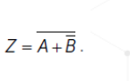

|  |  |  |  |  |
| --- | --- | --- | --- | --- |
| A | B |  |  |  |
| 0 | 0 | 1 | 1 | 0 |
| 0 | 1 | 0 | 0 | 1 |
| 1 | 0 | 1 | 1 | 0 |
| 1 | 1 | 0 | 1 | 0 |

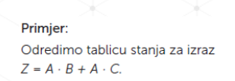

|  |  |  |  |  |  |
| --- | --- | --- | --- | --- | --- |
| A | B | C | A*B | A*C | A*B+A*C |
| 0 | 0 | 0 | 0 | 0 | 0 |
| 0 | 0 | 1 | 0 | 0 | 0 |
| 0 | 1 | 0 | 0 | 0 | 0 |
| 0 | 1 | 1 | 0 | 0 | 0 |
| 1 | 0 | 0 | 0 | 0 | 0 |
| 1 | 0 | 1 | 0 | 1 | 1 |
| 1 | 1 | 0 | 1 | 0 | 1 |
| 1 | 1 | 1 | 1 | 1 | 1 |

C) Pojednostavni



OVO JE 0

B + BPOTEZ JE 1, a 1+C=1, A*1=A

D) 