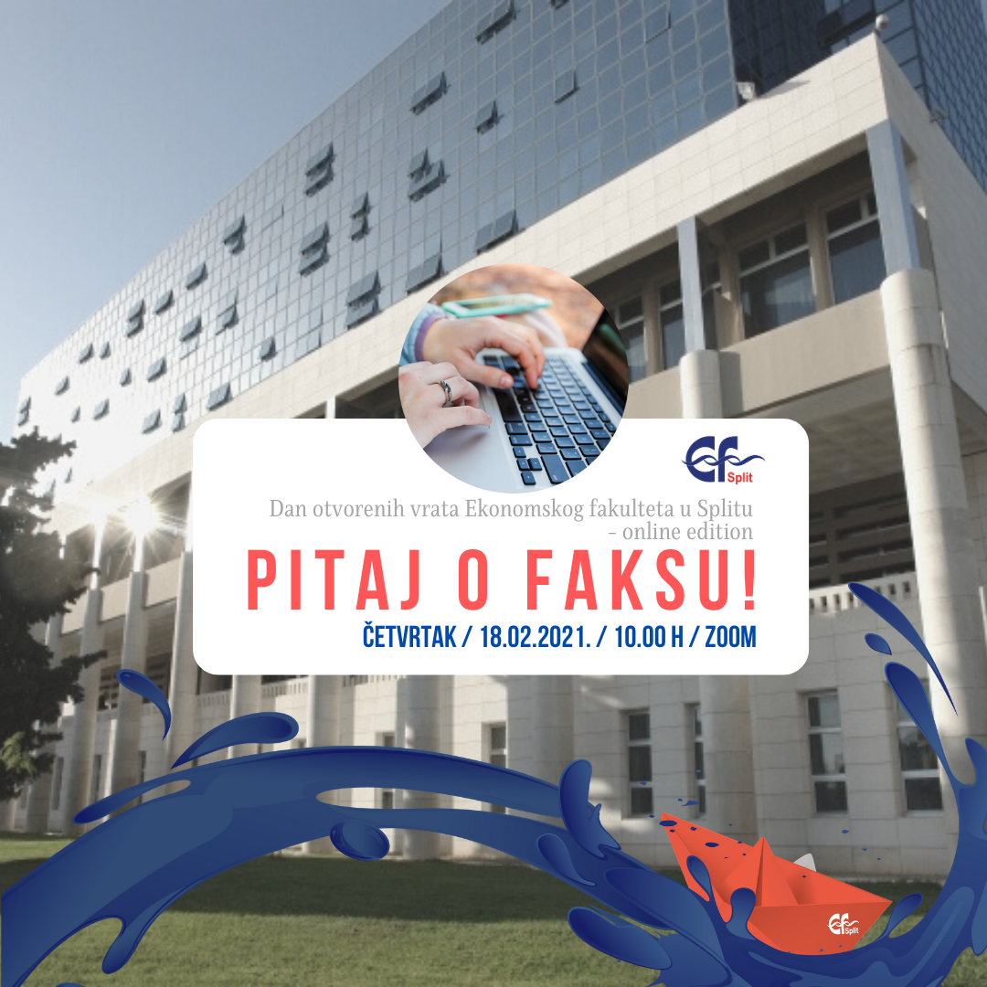

**Zoom / četvrtak, 18.02.2021. / 10:00 h**Link za pristup: <https://zoom.us/j/99474843855?pwd=WUJrL3prOEd6Ry96R2dRc2p3eUJLQT09>

Meeting ID: 994 7484 3855

Passcode: 174287