

Innovative Lifelong e-Learning for Professional Engineers

(e-ProfEng)

586391-EPP-1-2017-1-SE-EPPKA2-CBHE-JP

**Training in Electrical Engineering Discipline**

**Modelling and Simulation in Electrical Engineering**

**Teaching Materials for Topic 1**

**Modelling and Simulation of Engineering Systems**

**Authors:**

**Matej Žnidarec, P9 FERIT**

**Damir Šljivac, P9 FERIT**

Contents

Performance and empirical analysis of photovoltaics based on measurements 3

Data acquisition system and equipment 3

Empirical analysis of 5 PV modules made of different technologies 5

Performance analysis of 10 kW PV system 6

Photovoltaic system modelling and simulation 8

Load profile description 9

Microgrid model description 10

Objective functions description 11

Technical-economic analysis 12

Hardware in loop (HIL) simulations of off-grid microgrid 13

Off-grid microgrid model description 13

Simulations in Typhoon HIL SCADA 14

Simulations and results 14

Photovoltaic system design (experimental) 15

On-grid (grid-tie) photovoltaic system (10 kWp PV plant ETFOS1) 15

Off-grid (islanded) DC photovoltaic microgrid 16

Off-grid (islanded) AC/DC photovoltaic microgrid 16

AC/DC hybrid photovoltaic microgrid 17

# Performance and empirical analysis of photovoltaics based on measurements

Goal of this exercise is to perform empirical and performance analysis of 5 photovoltaic (PV) modules made of different technologies and 10 kWp PV system installed on the building roof based on real measurements taken from data acquisition system.

## Data acquisition system and equipment

Measurements used for the analysis are acquired by data acquisition system installed in the Laboratory for Renewable Energy Sources given in Figure 1. Data acquisition system continuously measures, analyses and stores measurement data in online database in a real-time.

Data acquisition system consists of three main sections:

* Data acquisition system of 5 PV modules made of different technologies
* Data acquisition system of 10 kWp PV system (2 PV technologies)
* Data acquisition of meteorological parameters on the test site

PV modules are connected to the AC distribution network over single-phase grid-tie micro-inverter with integrated maximum power point tracker (Figure 1) and represent a micro PV system. System for measurements is connected to the DC side of the inverter which measures output current, voltage and cell temperature of the PV module every second with various types of sensors.

10 kWp PV system consists of 2 PV strings (Figure 1). First PV string consists of 20 series-connected PV modules made of monocrystalline silicon (Bisol BMO 250) while second consists of 20 series-connected PV modules made of polycrystalline silicon (Bisol BMU 250). PV strings are connected to the three-phase grid-tie inverter over two inputs equipped with maximum power point tracker. The inverter (Kaco Powador 12.0 TL3) is connected to the distribution network. Measurements of electrical parameters are performed by the inverter itself.

Meteorological data is measured by weather station and pyranometer on the FERIT Osijek building roof where PV technologies are located. Weather station measures ambient temperature, air humidity, wind speed, wind direction and air pressure every minute while pyranometer (Kipp&Zonnen SMP3) measures solar irradiance every second. All measured data is sent to the data logger where they are processed and stored.

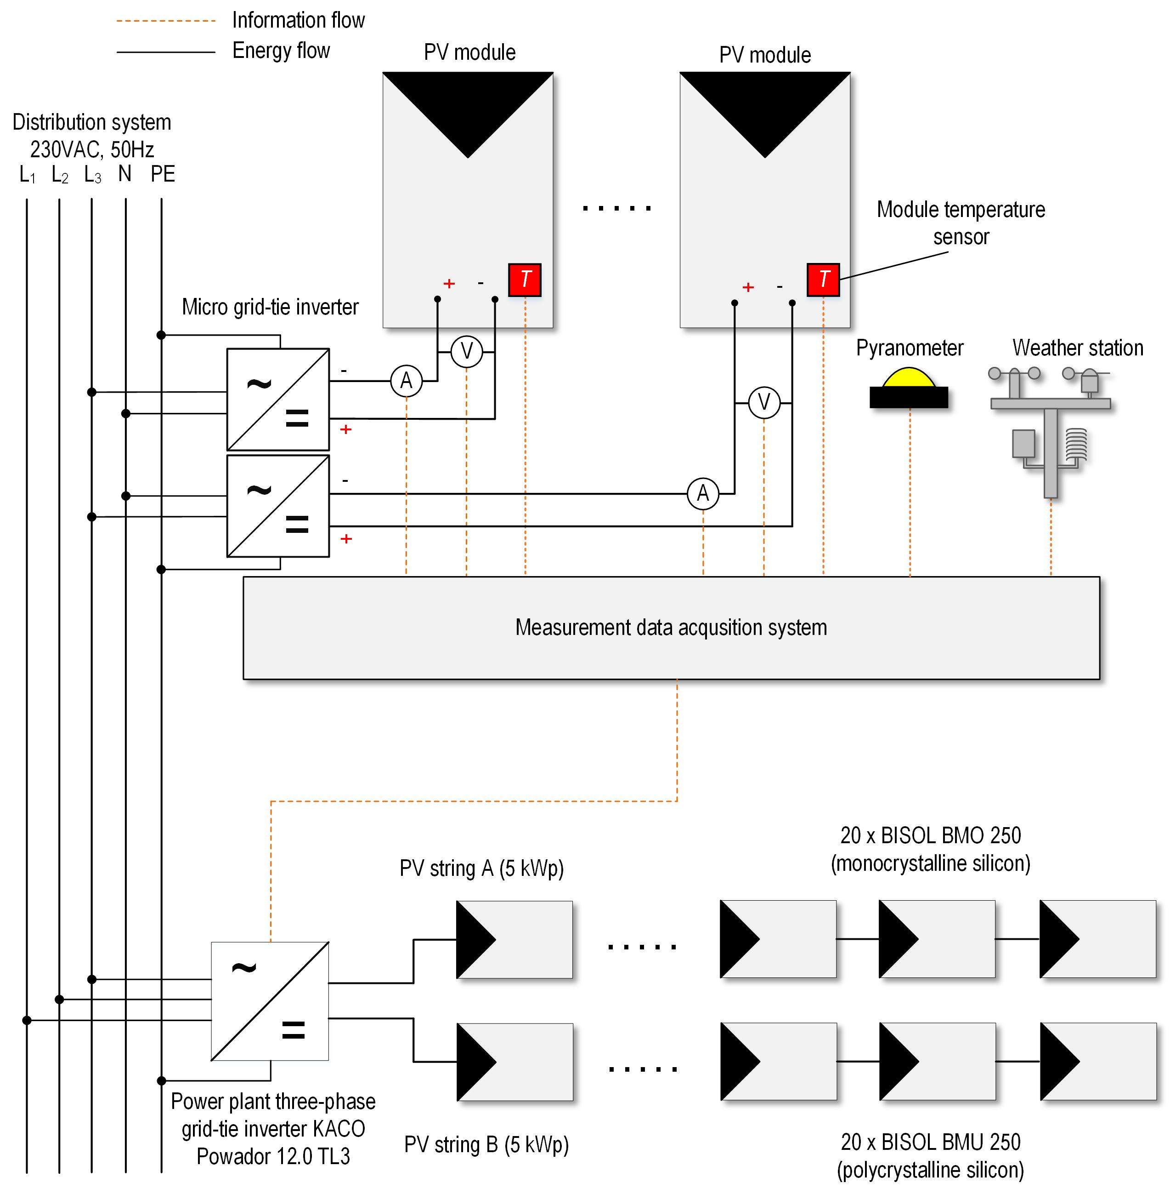

Figure 1. Data acquisition system for measurements

Technical characteristics of 5 PV modules made of different technologies are given in Table 1 while technical characteristics of three-phase grid-tie 10 kW PV plant inverter are given in Table 2.

Table 1. Technical characteristics of PV modules

|  |  |  |  |  |  |
| --- | --- | --- | --- | --- | --- |
| **Parameter** | **Bisol BMO 250** | **Bisol BMU 250** | **Masdar MPV100-S** | **Solar Frontier SF150-S** | **Panasonic VBHN240SE10** |
| **PV technology** | m-Si | p-Si | a-Si | CIS | HIT |
| ***P*MPP[W]** | 250 | 250 | 100 | 150 | 240 |
| ***U*MPP [V]** | 30.5 | 30.3 | 76 | 81.5 | 43.7 |
| ***I*MPP [A]** | 8.2 | 8.25 | 1.33 | 1.85 | 5.51 |
| ***η*mod [%]** | 15.3 | 15.3 | 7 | 12.2 | 19 |
| ***U*OC [V]** | 37.9 | 38.4 | 100 | 108 | 52.4 |
| ***I*SC [A]** | 8.8 | 8.75 | 1.57 | 2.2 | 5.85 |
| **NOCT [°C]** | 44 | 44 | n/a | 47 | 44 |
| ***γ* [%/°C]** | -0.35 | -0.4 | -0.2 | -0.31 | -0.3 |
| ***β* [mV/°C]** | -132 | -121 | -300 | -324 | -131 |
| ***α* [mA/°C]** | +4.5 | +4.9 | +1.57 | +0.22 | +1.76 |
| **A[m2]** | 1.63 | 1.63 | 1.43 | 1.23 | 1.26 |

Table 2. Technical characteristics of 10 kW three-phase grid-tie PV plant inverter

|  |  |
| --- | --- |
| **Parameter** | **Value** |
| **DC side** | |
| Maximum input power | 12 kW |
| Maximum power point tracker (MPPT) range | 280 - 800 V |
| Minimum DC voltage | 250 V |
| Maximum input voltage | 1000 V |
| Number of inputs/MPPT’s | 2 |
| Maximum input current | 22.4 A |
| **AC side** | |
| Maximum output power | 10 kW |
| Nominal output current | 14.5 A |
| Nominal voltage (phase-to-phase/phase-to-ground) | 400/230 V |
| Total harmonic distortion (THD) | 2.22 % |
| Maximum efficiency | 98 % |
| European efficiency (EU) | 97.5 |

## Empirical analysis of 5 PV modules made of different technologies

**(paper available on Loomen course)**

Download file from Loomen page of the workshop titled **Empirical analysis_PV modules.xlsx**. File contains measurements taken from data acquisition system for 5 PV modules made of different technologies for 5 sunny days in October 2017:

* 1st October 2017
* 2nd October 2017
* 15th October 2017
* 19th October 2017
* 20th October 2017

Figure 2 shows solar irradiance profile for the observed days. Furthermore, measurements are filtered in a way that minimum solar irradiance is set to 550 W/m2 (daytime), according to the standard IEC 61724-2 (Photovoltaic system performance - Part 2: Capacity evaluation method).

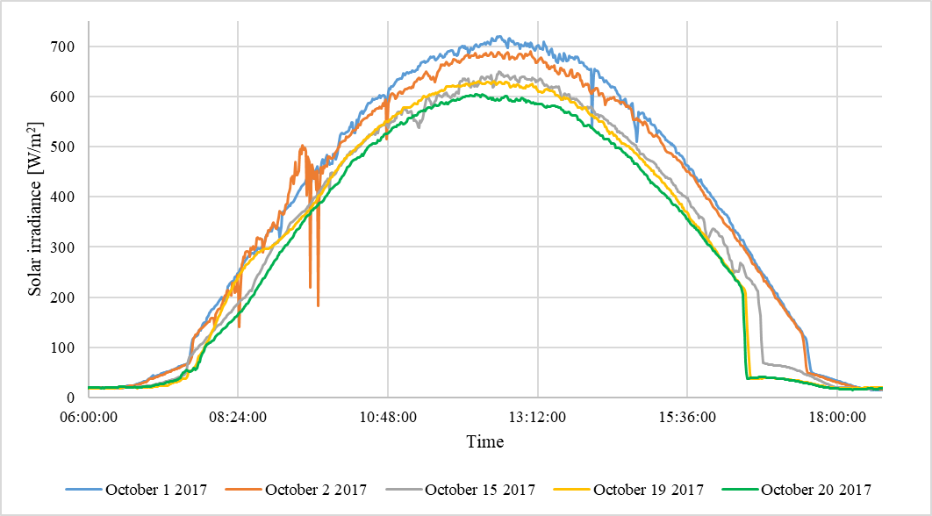

Figure 2. Solar irradiance profile of observed days

Open file in Microsoft Excel and show following relations of parameters with **scatter charts**:

* Module temperature *T*mod in relation to the solar irradiance *G*, *T*mod = f(*G*)
* Module temperature *T*mod in relation to ambient temperature *T*ok, *T*mod = f(*T*ok)
* PV module output DC current *I*MPP in relation to the solar irradiance *G*, *I*MPP = f(*G*)
* PV module output DC voltage *U*MPP in relation to the module temperature *T*mod, *U*MPP = f(*T*mod)
* PV module efficiency *η*mod in relation to the module temperature *T*mod, *η*mod= f(*T*mod)

**Paste charts in this file and write conclusive remarks based on empirical analysis based on measurements.**

## Performance analysis of 10 kW PV system

Download file from Loomen page of the workshop titled **Performance analysis_PV system.xlsx**. File contains measurements taken from data acquisition system for 10 kW PV plant for partially-sunny day 10th April 2018 and sunny day 1st August 2017.

Open file in Microsoft Excel and show following relations of parameters with **scatter charts**:

* Time-series of output **DC power** of monocrystalline and polycrystalline silicon PV strings for 10th April 2018 (partially-cloudy day) and 1st October 2017 (sunny day) on the same chart for each day, ***P*dc, string*=*f(*t*)**. Also, add solar irradiance time-series on second vertical axis on the same chart for each day, ***G=*f(*t*)**.
* Time-series of monocrystalline and polycrystalline silicon PV string **efficiency** for 10th April 2018 (partially-cloudy day) and 1st October 2017 (sunny day) on the same chart for each day, ***η=*f(*t*)**. Also, add module temperature time-series on second vertical axis on the same chart for each day, ***T*mod*=*f(*t*)**.
* Time-series of monocrystalline and polycrystalline silicon PV string **module temperature** for 10th April 2018 (partially-cloudy day) and 1st October 2017 (sunny day) on the same chart for each day, ***T*mod*=*f(*t*)**. Also, add solar irradiance time-series on second vertical axis on the same chart for each day, ***G=*f(*t*)**.

**Paste charts in this file and bring conclusive remarks based on performance analysis based on measurements.**

# Photovoltaic system modelling and simulation

**DOI: 10.1109/SST.2018.8564734**

In this part of the workshop, Hybrid Optimization Model for Multiple Energy Resources (HOMER) Pro microgrid software will be used for modelling and simulation of renewable energy sources microgrid. Software conducts simulations, optimisation and sensitivity analysis of renewable energy sources microgrids. Microgrid consists of PV array, Li-ion batteries, inverter/rectifier, wind turbine, biodiesel generator and utility (Figure 3 and Figure 4). It represents nearly zero energy building (nZEB) solution of FERIT Osijek building in which, according to the nZEB standard, annual produced electrical energy should be almost equal with the annual consumption.

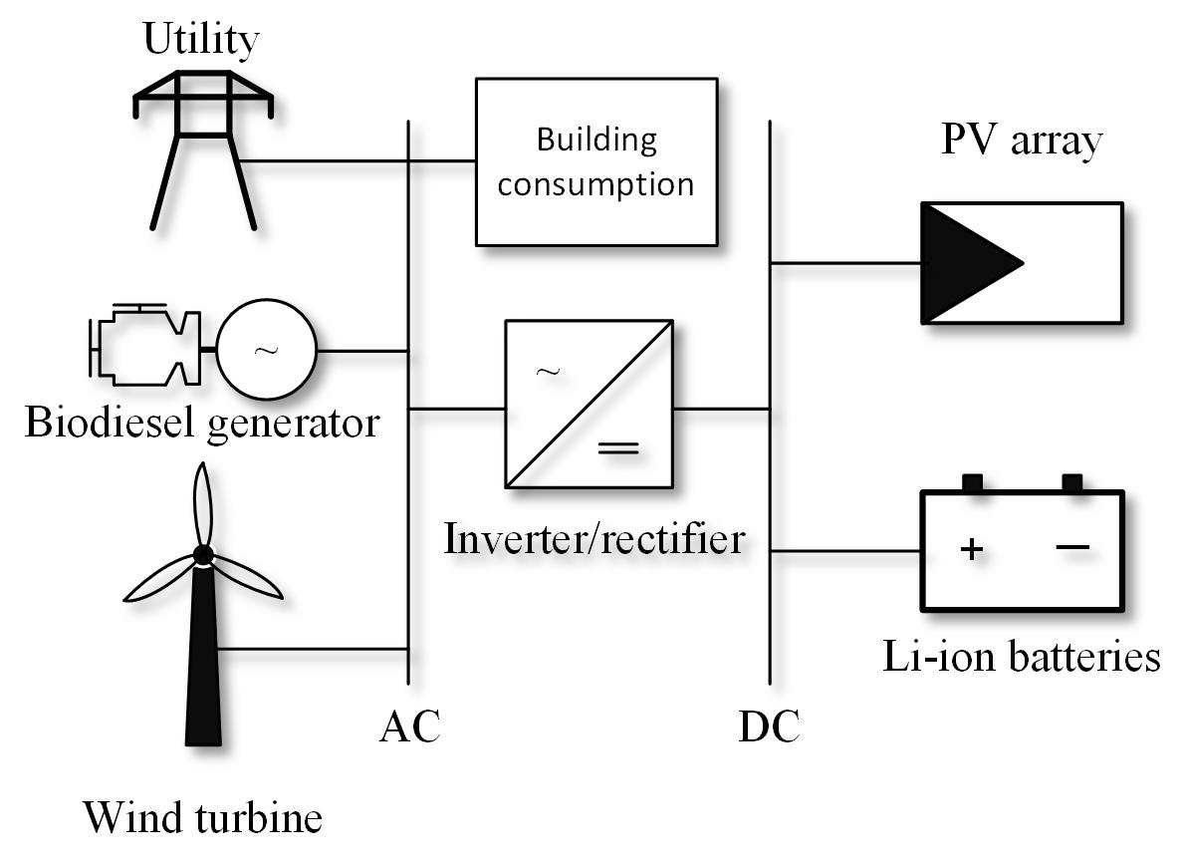

Figure 3. Proposed microgrid scheme for achieving nZEB standard of FERIT Osijek building

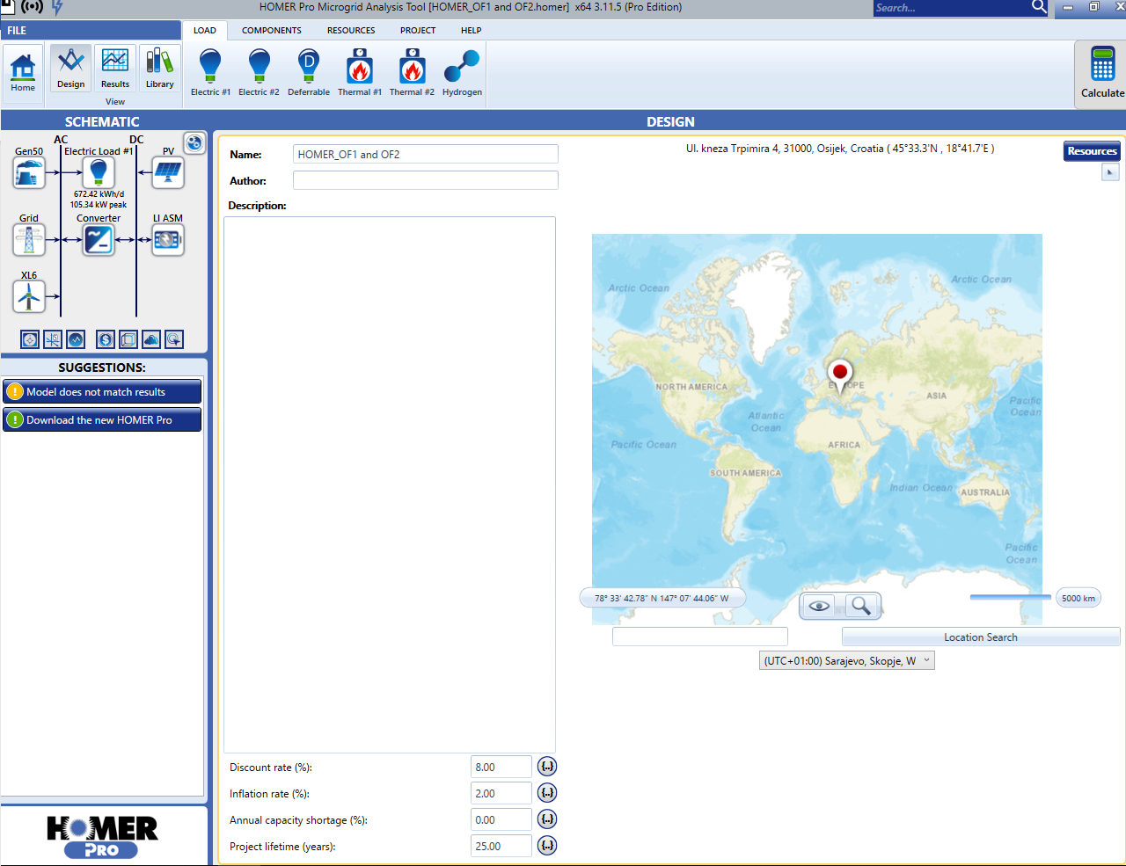

Figure 4. HOMER Pro interface of the proposed microgrid model

## Load profile description

Load profile construction is based on 15-minute average values of load measured on the point of common coupling of FERIT Osijek building with the distribution network. Measurements are analysed and presented graphically in Figure 5. Fig. 5 (left) shows averaged hourly load values based on the yearly measurements i.e. average consumption day for a whole year and averaged monthly values of load (right) i.e. average load for each month in a year.

|  |  |
| --- | --- |
|  |  |

Figure 5. Load profile

## Microgrid model description

The objective of this research is to achieve four proposed OFs given in this chapter along with the constraints. LCOE function used for all OFs is defined in (1) [7].

|  |  |
| --- | --- |
|  | (1) |

Where:

*Capitaln* - Total capital construction cost in the year *n*

*O & Mn* - Operation and maintenance costs in the year *n*

*Fueln* - Fuel costs in the year *n*

*Carbonn* - Carbon costs in the year *n*

*Dn -* Decommissioning and waste management costs in the year *n*

*r -* discount rate

*MWh* - Amount of electricity produced in a year *n*

**Mathematical model of the MG:**

Mathematical model of each component of the MG and constraints used for OFs are following.

1. PV array

Output power of the PV array *P*PV (*t*) is defined as in (2), where *G*(*t*) is irradiance in the hour *t*, *A* is the PV array area and *η*array is the efficiency of the PV array.

|  |  |
| --- | --- |
|  | (2) |

1. Batteries

Batteries state of charge constraint is defined as in (3), where *SOC*batt (*t*) is battery state of charge in the hour *t* and *SOC*batt,min and *SOC*batt,max are minimum and maximum value of the batteries state of charge, respectively.

|  |  |
| --- | --- |
|  | (3) |

Output power of the batteries is also constrained by maximum current output as in (4), where *I*batt (*t*) is the battery output current in the hour *t* and *I*batt,max is the maximum battery output current per battery.

|  |  |
| --- | --- |
|  | (4) |

1. Inverter/rectifier

Inverter/rectifier is constrained as in (5), where *P*inv/rec (*t*) is the inverter/rectifier output power in the hour *t* and *P*inv/rec,rated is the maximum output/input power of the inverter/rectifier.

|  |  |
| --- | --- |
|  | (5) |

1. Wind turbine

Output power of the wind turbine *P*wind (*t*) is defined as a function of the wind speed given in .

|  |  |
| --- | --- |
|  | (6) |

Where:

*v*(*t*) - Wind speed in the hour *t*

*v*cut-in - Cut-in wind speed of the wind turbine

*P*wind (*t*) - Wind turbine output power in the hour *t*

*v*n - Wind turbine rated wind speed

*ρ*air - Air density

*A*w - Effective disk area

*c*p - Power coefficient

*η*w - Wind generator overall efficiency

*v*cut-out - Cut-out wind speed of the wind turbine

*P*n - Rated output power of the wind turbine

1. Biodiesel generator

Output power of the biodiesel generator *P*biogen (*t*) is defined as in (7), where *P*biogen,rated is nominal output power and *P*biogen,min is the minimum output power of the biodiesel generator.

|  |  |
| --- | --- |
|  | (7) |

## Objective functions description

1. Objective function (OF) 1: Minimum LCOE

Goal of this OF is to find minimum LCOE for the proposed MG in an on-grid state. The mathematical expression of the OF 1 is given in (8).

|  |  |
| --- | --- |
|  | (8) |

1. Objective function 2: nZEB with ideal utility

Goal of OF 2 is to find minimum of function given in (9) i.e. net electricity exchange with the utility in a year should be minimum and meet the constraint defined in (10). Utility is modelled as an ideal i.e. there are no blackouts during the year.

|  |  |
| --- | --- |
|  | (9) |

Constraint:

|  |  |
| --- | --- |
|  | (10) |

Where:

*MWh*p - Purchased electricity from the utility in a year

*MWh*s - Sold electricity to the utility in a year

*MWh*net,max - Maximum net electricity exchange in a year

1. Objective function 3: island (off-grid)

In this case, an island state of the MG is studied. OF 3 given in (12) describes the balance between produced power by PV array, batteries, wind turbine and biodiesel generator and demand in the hour *t.* This condition needs to be satisfied in order to MG maintain the stability of the operation.

|  |  |
| --- | --- |
|  | (12) |

Where:

*P*bat (*t*) - Output power of the batteries in the hour *t*

*D* (*t*) - Electrical demand in the hour *t*

## Technical-economic analysis

Use HOMER Pro microgrid software to conduct technical-economic analysis on the developed microgrid using following files for certain objective functions:

* OF1 and OF2 - **HOMER_OF1 and OF2.homer**
* OF3 - **HOMER_OF3.homer**

Write results of the total NPC, Levelized COE (LCOE) and operating cost in Table 3.

Table 3. Results of the simulations

|  |  |  |  |
| --- | --- | --- | --- |
| Case | Total NPC | Levelized COE (LCOE) | Operating cost |
| OF1 (optimal) |  |  |  |
| OF2 (nZEB on-grid) |  |  |  |
| OF3 (off-grid) |  |  |  |

# Hardware in loop (HIL) simulations of off-grid microgrid

**DOI: 10.1109/SST.2018.8564663**

In this part, Typhoon HIL (Hardware In Loop) simulator will be used for real-time simulations of off-grid microgrid with renewable energy sources.

The Typhoon HIL Control Center integrates all the standard software components:

1. Schematic Editor
2. HIL SCADA
3. Script Editor
4. Typhoon HIL Test Suite

The TyphoonHIL Schematic Editor (henceforth referred to as Schematic Editor) is intended to support a number of components and power electronics blocks that can be used as building blocks for modelling power electronics systems in real-time on HIL402/60x hardware platforms.

Typhoon HIL SCADA is a simple, easy to use graphical environment that allows you to create your own specific interface with the real-time model. HIL SCADA is the successor of the widely-used tools, HIL Control Panel and Custom UI. Using HIL SCADA widgets, combined with the strength of Python macro and expression scripts, you can control and observe not only HIL simulation but also your own external device(s).

The HIL SCADA application has two basic functions:

1. it downloads simulation models to the HIL platform, and
2. it controls the emulation process, parameters and outputs

When HIL SCADA is started, it will show the recently opened compiled Model (.cpd) files. After you select the desired model, HIL SCADA will attempt to establish a connection with the HIL device and upload Model settings to the HIL device.

## Off-grid microgrid model description

Off-grid microgrid consists of battery system, wind turbine, photovoltaic system, diesel generator and variable load (Figure 6). The model uses external data files for input of:

* solar irradiance for PV system
* wind speed for wind turbine
* apparent power for variable load

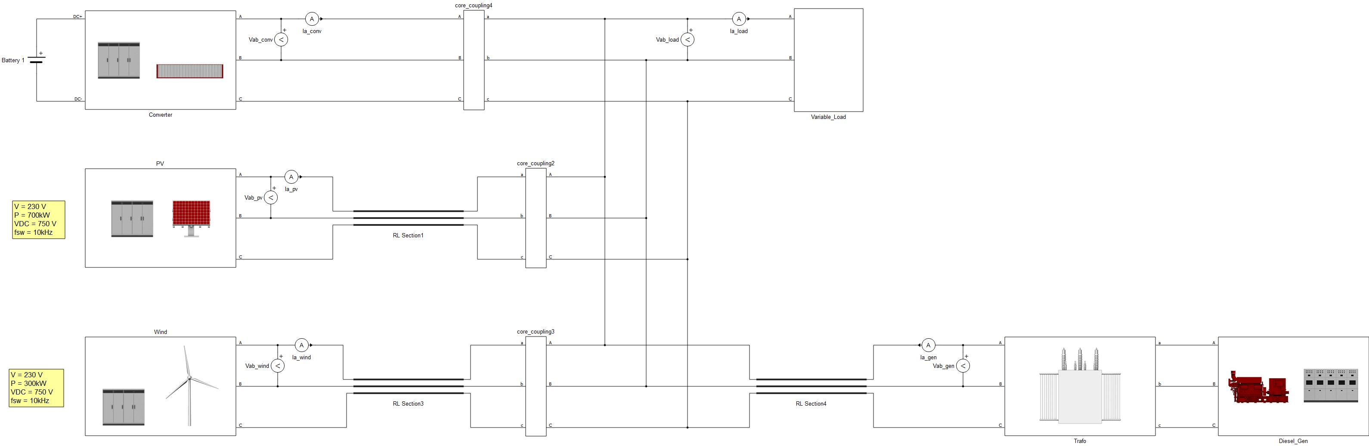

Figure 6. Off-grid microgrid model in Typhoon HIL Schematic Editor

## Simulations in Typhoon HIL SCADA

After the model is compiled, Typhoon HIL SCADA opens (Figure 7).

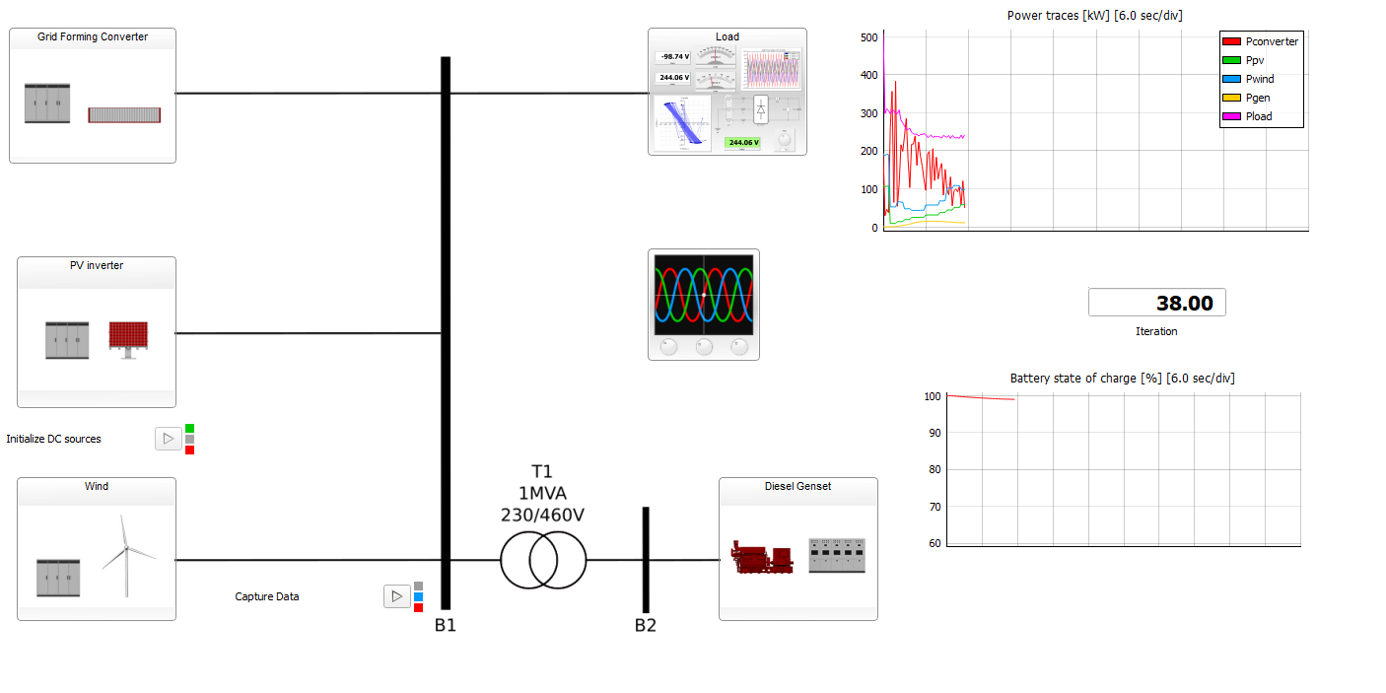

Figure 7. Typhoon HIL SCADA of the model

## Simulations and results

Use Typhoon HIL software to analyse the operation of off-grid microgrid by performing the following:

* Open Typhoon HIL Control Center and enter Schematic Editor
* In the Schematic Editor, open model titled **uGrid_A7.tse** located in **uGrid_A7** folder
* Compile and open model in Typhoon HIL SCADA
* In Typhoon HIL SCADA, open panel titled **CUI.cus** in **uGrid_A7 Target files** folder
* Analyse the operation of the model

**Task:**

* Add trace graph for active power of the variable load *P*
* Add trace graph for reactive power of the variable load *Q*
* Add trace graph for frequency of the system *f*

# Photovoltaic system design (experimental)

In this part, wiring diagram of different types of photovoltaic systems/microgrids which utilize photovoltaics for electricity generation are presented and basic principles of work are described. All of these systems are available for presentation in the Laboratory for Renewable Energy Sources.

## On-grid (grid-tie) photovoltaic system (10 kWp PV plant ETFOS1)

Wiring diagram given in Figure 8 represents a typical household size on-grid (grid-tie) photovoltaic system connected either to the distribution grid or on household installation switchboard. Given 10 kWp photovoltaic system consists of two 5 kWp photovoltaic strings made of 20 series-connected photovoltaic modules. First photovoltaic string consists of monocrystalline silicon PV modules Bisol BMO 250 with rated power of 250 Wp while the second consists of polycrystalline silicon PV modules Bisol BMO 250 with rated power of 250 Wp. Photovoltaic strings are connected to 10 kW three-phase grid-tie inverter with two inputs/maximum power point trackers (MPPT) which converts DC into AC electricity suitable for the AC distribution network (230 V AC, 50 Hz). Described system is installed on FERIT Osijek building roof next to the Laboratory for Renewable Energy Sources.

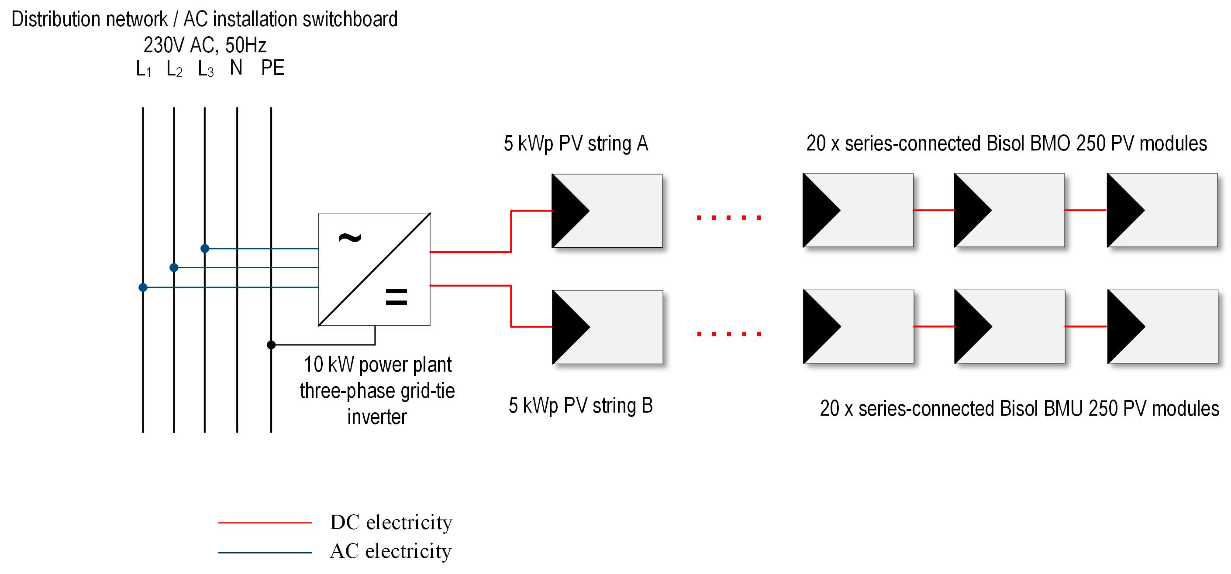

Figure 8. Wiring diagram of on-grid (grid-tie) photovoltaic system model

## Off-grid (islanded) DC photovoltaic microgrid

Wiring diagram of off-grid (islanded) DC photovoltaic microgrid is given in Figure 9. Presented microgrid consists of photovoltaic module/s, charge controller, lead-acid batteries and DC loads. Photovoltaic modules are connected to the charge controller’s MPPT which extracts maximum power out of the modules. Furthermore, charge controller supervises battery state of charge, charging/discharging process and supply of the DC loads. It also prevents over-charging and over-discharging of the batteries. DC loads are supplied either from the photovoltaic modules when the electricity is available or from the batteries in cases of energy deficit. Described system is connected and available for presentation in the Laboratory for Renewable Energy Sources.

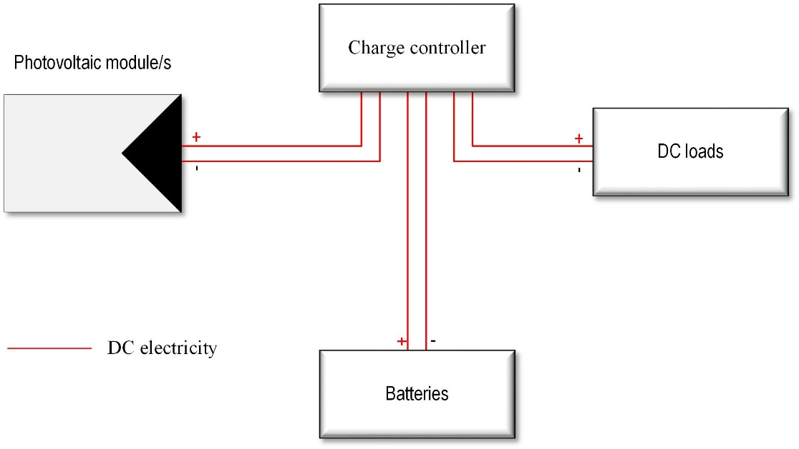

Figure 9. Off-grid (islanded) DC photovoltaic microgrid model

## Off-grid (islanded) AC/DC photovoltaic microgrid

Wiring diagram of off-grid (islanded) AC/DC photovoltaic microgrid is given in Figure 10. Presented microgrid consists of photovoltaic module/s, charge controller, lead-acid batteries, off-grid inverter, AC and DC loads. This type of microgrid is an upgraded version of an off-grid (islanded) DC photovoltaic microgrid with an off-grid inverter and AC loads. Unlike off-grid (islanded) DC photovoltaic microgrid, this type can supply both AC and DC loads. AC loads are supplied from an off-grid inverter which converts DC electricity supplied from batteries into AC energy suitable for the AC loads (230 V AC, 50 Hz). Batteries serve as an energy storage which balances electricity supplied by the photovoltaic module/s and consumed energy by DC and AC loads. Described system is connected and available for presentation in the Laboratory for Renewable Energy Sources.

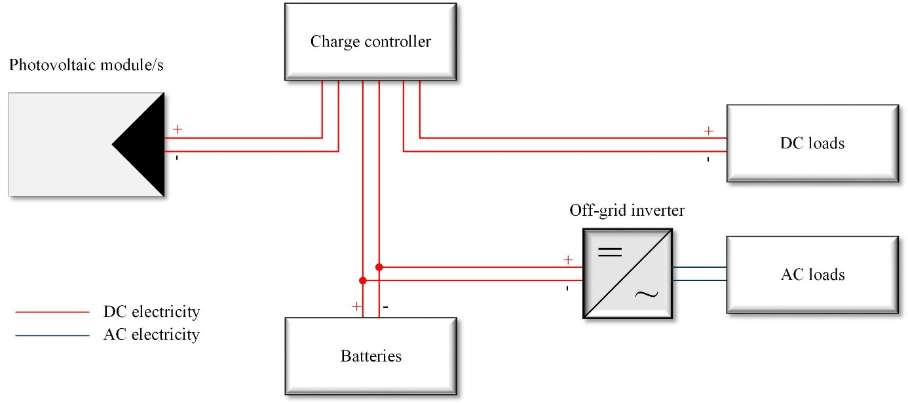

Figure 10. Off-grid (islanded) AC/DC photovoltaic microgrid model

## AC/DC hybrid photovoltaic microgrid

Wiring diagram of AC/DC photovoltaic microgrid is given in Figure 11. Presented microgrid consists of photovoltaic module/s, charge controller, lead-acid batteries, inverter/charger, additional generator/electricity source, AC and DC loads. This type of microgrid utilizes additional generator/electricity source which can be either wind turbine, fuel-cell, biodiesel generator or AC distribution network. Inverter/charger represents two-direction power electronic converter which can have multiple roles depending on the microgrid type.

In a case of an off-grid (islanded) microgrid, it can serve either as a battery charger when batteries need to be charged by the additional generator or as an inverter which converts DC electricity supplied by the batteries into AC electricity needed for AC loads in a case when there is enough energy stored in the batteries.

In a case of an on-grid (grid-tie) microgrid, it can serve as an uninterruptable power supply (UPS) which supplies AC sources in a case of grid blackout in the inverter mode. When the grid is available, it keeps the batteries fully charged for the case of an emergency in the battery charger mode.

Described system is connected and available for presentation in the Laboratory for Renewable Energy Sources.

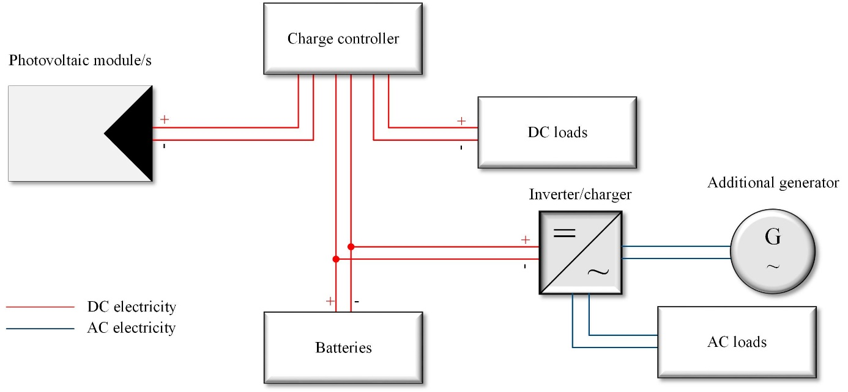

Figure 11. AC/DC hybrid photovoltaic microgrid model