**TEXT 1**

**Greetings & Communication**

Americans might greet with a handshake; however, there are other greetings out there of which you should be aware. For example, in Japan, people bow, and in Italy and some Slavic countries, people kiss cheeks … and then if you are a member of the Freemasons, well, that gets too complex for us to go into in this guide.

**The handshake**

In parts of Northern Europe, a quick, firm handshake is the norm, but in parts of Southern Europe, Central and South America, a handshake is longer and warmer. Beware that in Turkey, a firm handshake is considered rude and aggressive, and in certain African countries, a limp handshake is normal. In Islamic countries, men should generally never shake the hands of women.

**Eye contact**

In the Czech Republic and parts of Germany, it is considered a lack of respect to not look each other in the eye when toasting with an alcoholic beverage … and not just the first toast, but EVERY single time you clink those glasses together! So, be prepared to know your new friends’ eye color quite well by the end of a long night out. In the United States and Canada, intermittent eye contact is extremely important in conveying interest and attention.

In many Middle Eastern cultures, intense eye contact between the same genders is often a symbol of trust and sincerity; however, between opposite genders, especially in Muslim cultures, anything more than BRIEF eye contact is considered inappropriate. Additionally, in Asian, African, and Latin American cultures, extended eye contact is considered a “challenge”. The Japanese tend to consider even brief eye contact uncomfortable. And, in some cultures, a woman should look down when talking to a man.

Source:<https://www.backpackertravel.org/backpacker-101/on-the-road/dealing-different-customs-cultures/>, 20 May 2018

**1. Read the text above and decide whether the statements are true or false!**

|  |
| --- |
| 1. The Germans greet their friends by kissing on the cheek. **T / F** |
| 1. In German culture, looking into somebody's eyes is considered as polite, while in American culture any longer eye contact is avoided. **T / F** |
| 1. In some cultures, the customs of communication differ due to gender. **T / F** |
| 1. A firm handshake is considered polite in Turkey, as well as in the North European countries. **T / F** |
| 1. Both the Italians and the Slavs have similar customs when greeting and communicating with others. **T / F** |

**2. Na prazne crte napiši o kojem se običaju radi te kojoj kulturi pripada!**

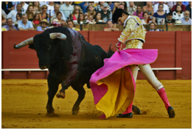**a)**

**_____________________________**

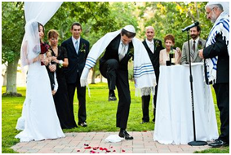

**b)**

**_____________________________**

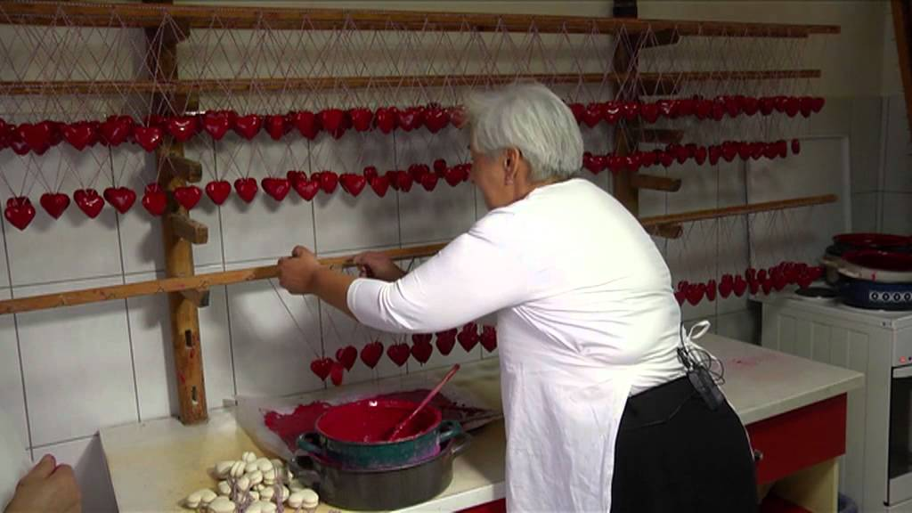

**c)**

**_____________________________**

** d)**

**______________________________**

culture: *croatian culture, irish culture, spanish culture, jewish culture, spanish culture*

custom: *Gingerbread, Bullfighting, Going Green for St. Patrick's Day,* [*Breaking The Glass*](http://thebigfatjewishwedding.com/2013/breaking-the-glass/)